Introduction to Quantum Mechanics
At distances up to approximately two orders of magnitude the distance between atoms, the laws that determine classical mechanics no longer work correctly, and we must use quantum mechanics instead.
There are a number of principles related to this topic. Some of the most important are:
It is impossible to know exactly where an atomic particle is, and what its motion is at the same time.
- We often need to represent the particle not as an object that is in a certain position, but as an object that has some spatial probability function to say where it is in space.
- This is the core of the Heisenberg Uncertainty principle.
- This leads to the concept of a wavefunction and also to wave-particle duality. Electrons must be treated in certain cases as waves in order to understand the device behaviour, other time a particle treatment is more appropriate.
- Bound particles can only gain energy in fixed increments, going from one energy level to another. These energy levels represent different probability functions that the particle is in a certain region
- e.g If one goes from the most tightly bound state to the 2nd energy state in hydrogen atom then the region where you are most likely to find the electron is slightly further away from the atomic core.
- When we add particles into a system they can behave in one of two ways:
- Fermi-Dirac Statistics, say that the particles, called Fermions, must obey the Pauli Exclusion Principle. This principle states that no two particles can share the same state at the same time. This is the situation as we add electrons to an atom.
- Bose-Einstein Statistics apply to Bosons, which do not obey the Pauli Exclusion Principle so one state can have many particles occupying it.
- Both these statistical forms reduce to so-called Maxwell-Boltzmann Statistics at large distances.
- Many device concepts, including electrons tunnelling through a barrier, the semiconductor bandgap and the concept of effective mass come from a quantum mechanical treatment of the topic.

Atoms to Compounds.
In an atom Fermic-Dirac statistics apply. This means that only one electron can fit in each state. There are two states in 1s level (on for electron spin 1/2 and on for spin -1/2. The exact quantum mechanics between these states does not need to worry us here. All we need to remember is that electrons keep filling up the available states until, in an atom, we have as many electrons as there are protons in the atom core. Consider the case for a silicon atom below:

A key point is that the higher energy the electron state the further it is from the atom core. Thus it is logical that bonds between atoms only involve the highest energy electrons. The most tightly bound, lowest energy electrons are of no interest to semiconductor engineers (except for certain very specialist devices such as X-ray detectors.
In chemical bonding between two atoms the states in the outermost filled levels overlap and the electron states are shared. As two electrons cannot have the same state (Pauli Exclusion Principle) there is a small splitting between the two states.

If we go to many atoms then there are more splittings in the overlapping energy states and instead of discrete energy levels we obtain a BAND of overlapping states infinitesimally closely spaced in energy (10⁻²² eV) apart. In a semiconductor the electrons usually all fill the bonding band, which we call the valence band. There next atomic energy levels that overlap will lead to a band that is empty of electrons. This is called the conduction band. There usually a gap between the two bands called the bandgap, where it is forbidden for the electrons to exist (at least in a perfect crystal…).

Electrons can be excited from the valence band to the conduction band by absorbing energy, such as light. If they do so they leave a hole in the electron population in the bonding state. This hole can then move around in the valence band.
NOTE that completely empty bands do not have any carriers to allow conduction. Similarly completely full bands have no empty states for electrons to move into so they also cannot conduct.

Metals-Semiconductors-Insulators
The band description can be used to describe the into three broad categories, based on their ability to conduct electricity that we can classify solids into:
- Insulators
- Semiconductors
- Metals
In Insulators the energy difference between the valence and conduction band is very large. Electrons cannot easily gain enough energy to make this jump (very high temperature, or deep ultra-violet light) and so there are very few free carriers in the material.
Semiconductors, are in many respects similar to insulators. However the key difference is that it only takes a relatively small amount of energy to release the electrons from the bonds (e.g. infrared or visible light). This means that the bandgap in this case is smaller. In this case some generation and recombination can occur at room temperature leading to a number (usually small) of electrons and holes in the conduction and valence bands, respectively.
In metals the bonding arrangement is such that the bandgap has disappeared entirely. That is the valence band, where the bonds are and the conduction band overlap to form one composite band, with no bandgap. The outer electrons can easily move around in the material at any temperature.

Schrödinger's Wave Equation
Schrödinger's equation is an equation we can use to look at the behaviour of an electron when it is in small dimensions. It allows us to examine the behaviour of electrons when a wave, rather than particle analysis must be used. In this case the electron is treated as a wavefunction.

De Broglie relationship.
Let us start by considering the de Broglie relationship. This states that for all particles, including photons and electrons. The wavelength of the particle can be given by:
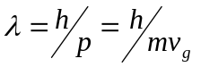, where, h, is Planck’s constant; p, is particle momentum, and v_{g} is the group velocity of the particle.
This equation has been experimentally proved -- e.g. electron diffraction patterns.

Particle and Wave behaviour
Any equation for quantum mechanical behaviour must be compatible with those equations that are known to apply in classical mechanics. Let us equate kinetic energy with the energy of a wave:
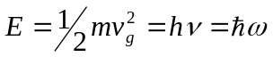, where ν is frequency, ω is angular frequency (=2πν), and ħ is h/2π.
Now let us introduce k the wavenumber, (or wavevector), where k=2π/λ. Then, differentiate the equation for E:
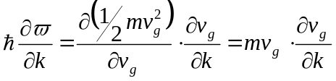
We now define 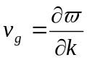 to get 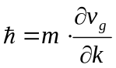and hence 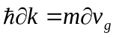
Which can be integrated to get: 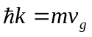
Substituting λ for k we obtain the de Broglie relationship: 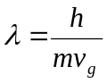
The key link between the particle and wave behaviour is that .

Definition and Meaning of Schrödinger's Wave Equation
Schrödinger's Equation can also be shown to equivalent to a classical mechanics equation. However, this will not be shown here. It is not an equation that can be derived from first principles, which is the same as the classical equations. However both the quantum and classical equations do explain experimental observations. The time independent form of the equation is given by:
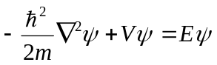
where ψ is the wavefunction of the electron and V is the potential in which the electron moves.
This equation can be equated to the classical equation of:
Kinetic Energy + Potential Energy = Total Energy
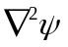can be rewritten in one dimension (to which most semiconductor problems can be reduced in the first approximation) as 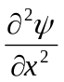. E is the total electron energy and m is the electron mass.
The key point about Schrödinger's Equation is that we can use it to determine a function for the probability of finding an electron in some region of space. In three dimensions: 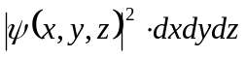 is the probability of finding the electron in the volume given by dx.dy.dz. If we are interested only in one dimension the the equation can be reduced accordingly.
It should be noted that 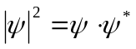 where 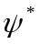 is the complex conjugate of . It should also be noted that if we integrate the probability function from 0 to ∞ then the answer must be one.
has usually two forms of behaviour. It can be based on a sine wave or on an exponentially decaying function. For a sine wave:

In this case the probability function tells us that the electron is less likely to be found near the centre, but more likely half way out towards the sides.

Energy and Schrödinger's Wave Equation
We have already said that kinetic energy.in the equation is given by the 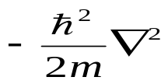 term.
Thus for momentum, p: 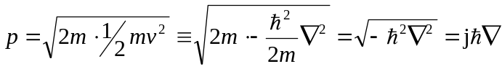
In one dimension we can therefore say that the momentum "operator" is equivalent to 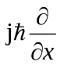
We can apply this operator to the wavefunction to get the average value of momentum, <p> of the state we are looking at:
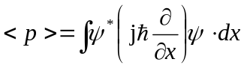
We can similarly get the average value any other quantity as long as we know its quantum mechanical operator.

General Solution of Schrödinger's Wave Equation
The general solution of the (time independent) equation in 1-D is given by
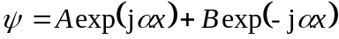 where 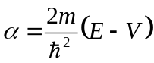
This can be regarded as the supposition of a forward and backward travelling wave.
***EXERCISE*** Check this by substitution

